MED D - Expressed Consent (Ship Consent)

MED D - Expressed Consent (Ship Consent)
High Level Process
Expressed Consent General Information
Expressed Consent Decision Table
Ship Consent Requested Notifications
Viewing Ship Consent Notes in PeopleSafe
PACE Plans Excluded from Expressed Consent
Authorized Persons Who Can Give Expressed Consent
Processing Ship Consent Hold Prescriptions/Orders
Ship Consent Requested Notification Options
Returned Goods
Beneficiary Calls to Cancel Order Previously Consented For
Adding/Removing Consent Required on Future Orders
Resolution Time
FAQs
Expressed Consent Billing and Payment Questions
How does Expressed Consent Affect Orders
Who Can Handle Expressed Consent Calls?
Related Documents

Description: This work instruction covers the process for beneficiaries to give ship consent for their medications.

High Level Process
- Determine the Status of the medication(s) in question.
- If status is Indefinite Hold place a refill order for the prescription. Refer to Prescription (Rx) Refill/Renewal (Order Placement) and document the call.
- If status is Ship Consent Hold, proceed to next step.
- Select the prescription(s) on Ship Consent Hold from the Order Placement screen.
- Obtain verbal expressed consent for the prescription(s) to be filled.
- If consent is not given, select Don’t Ship and assist the beneficiary with any other questions.
- If consent is given, select Ship Now.
- Continue processing as a Refill Order.

Top of the Document

Expressed Consent General Information
ALL MED D Plan sponsors must obtain and document EXPRESSED Consent (also known as Ship Consent) from the beneficiary on all non-beneficiary initiated prescription fills. Refer to Expressed Consent Decision Table to determine which scenarios Express Consent is required or not required.

Note: If consent is required, the beneficiary must provide their Consent by responding to the automated Ship Consent Requested Notification (phone, text or email) or by contacting MED D Customer Care.

Top of the Document

Expressed Consent Decision Table
Refer to the following:

If the beneficiary initiates the refill (IVR, Website or by an Inbound call), CMS sees this as EXPRESSED Consent.
- This includes Refills and New prescriptions submitted by mail to the mail order pharmacy.

Scenario | New, non- beneficiary initiated Rx, received directly from prescribers (via electronic prescribing (phone or fax) | Pharmacy has an indication beneficiary has elected Hospice or LTC | Beneficiary calls with payment information for an order which would otherwise have required consent | Rx where co-pay is more than $1000.00/High Copay Limit and call is required | Beneficiary's prescription is out of refills or has expired and the New Rx functionality (Care, IVR, or Web) is utilized to obtain a new prescription | Beneficiary mails a prescription to Mail Order
Required | If beneficiary has NOT filled at least one Rx using CVS/Caremark Mail Service Pharmacy under their current plan in the past twelve (12) months. | Required | Consent confirmed at time of payment with Customer Care | Consent confirmed at time of call, or via LINKS request process | Required if first fill under the beneficiary’s current plan (Example: Renewal is first fill under a new plan). | N/A
Not Required | If beneficiary has filled at least one Rx using CVS/Caremark Mail Service Pharmacy under their current plan in the past twelve (12) months. | N/A | N/A | N/A | If beneficiary has filled at least one/any Rx using CVS/Caremark Mail Service Pharmacy under their current plan in the past twelve (12) months. | Beneficiary has initiated the prescription fill.

Top of the Document

Ship Consent Requested Notifications
With this mandate, plans place automated Ship Consent Requested Notifications to the beneficiary after a non-beneficiary initiated prescription fill has been properly adjudicated for the first time the beneficiary uses mail service or uses mail service under their new plan.

Notifications can be sent via phone, email, or text. The method of notification is based on the beneficiary’s CMP preference that has been selected. Text messages sent by CMP will display as a short code, which is a 5-6 digit phone number used by businesses. (Example: 53333)

Note: The link within the Ship Consent Requested Notification email or text will be active for 72 hours. However, beneficiaries are able to provide consent and release orders placed on Ship Consent Hold after the 72 hour window. Beneficiaries will no longer need to call Customer Care to provide consent to release the order hold. This includes both Patient Denied Ship Consent (Reason code 31) and Patient Ignored Ship Consent (Reason code 32).

The notification will contain a link to allow the beneficiary to authorize ship consent. This option will not require them to login or create an account.

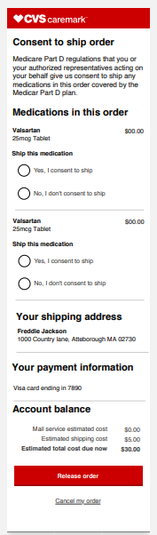

Note: Beneficiaries that receive digital notifications (text/email) will NOT receive notification phone calls.
Refer to MED D - Expressed Consent (Ship Consent) Digital Portal Job Aid.

Note: For CMP preference of a phone call, the Welltok IVR outreach only includes the drug name and does not include other details of the Rx.
The outreach includes:
- Advising the beneficiary their prescription is ready
- Advising the beneficiary their consent is needed before the prescription fill process can move forward
- Obtaining consent on the initial outbound call if the beneficiary answers the call or responds to the text or email.
  - Beneficiary is authenticated by verifying:
    - Name (First & Last)
    - DOB
    - Zip Code
- Asking the beneficiary to call Customer Care if consent is not obtained on the automated outbound call

If the outbound Ship Consent Request Call fails to connect with the beneficiary, a message will be left asking for a return call to provide consent.
- Beneficiaries will see the following number display: CVS Caremark 1-866-730-7569.
- A PIN number (7 digits) will also be provided
- The PIN number will access a message Lockbox so the beneficiary can consent as to whether they want the prescription to be filled.
Notes:
- The beneficiary can bypass the PIN if they call back on the same phone number and if they only have one set of prescriptions on hold.
  - The beneficiary will have two options: Yes or No
- If the PIN number is required and the PIN number is entered incorrectly, the verification of the order is not complete and the call is transferred to MED D Dedicated Ship Consent Care Line.
- If the beneficiary cannot receive the call in English or Spanish, the order(s) in question would move to indefinite hold and s/he would receive a letter about the medications awaiting shipment.

Ship Consent Calls are attempted four (4) times over a period of (2-3) days to the beneficiary’s primary phone number on file. A letter will be sent to the following beneficiaries:
- Not reached by CMP preference (phone, email, or text) after 4 attempts
- Missing/wrong telephone number on file or missing/wrong email address
- On the vendor’s CVS Caremark Do Not Call list
- Missing/wrong zip code
Note: The Expressed Consent self-service line is available at 1-855-479-3662 or if the beneficiary would like the order and prefer to speak to a Representative, they can call Customer Care at 1-800-758-9431.

The MED D - Expressed Consent HOLD Lttr TRA126-49-XXXX 29142a letter highlights the following details:
- Describes the new Medicare rule that started on 01/01/2014
- Telephone outreach was not successful.
- The beneficiary’s prescription is being held for patient’s consent to ship.
- If the beneficiary does not respond, the order will not be shipped.

The beneficiary does have the option to request the medication be placed on hold.
- In this situation, a letter will be sent to the beneficiary verifying their choice.
  - The MED D - Beneficiary Initiated HOLD Request Letter TRA096-49-6158 letter highlights the following details:
    - A beneficiary’s prescription is on hold due to:
      - A request received to hold a prescription OR
      - A prescription for the same medication was recently filled.
    - Advises beneficiary to contact Customer Care when they are ready to order this prescription.

CCR Note: View these letters in the Communications History tab in PeopleSafe.

Top of the Document

Viewing Ship Consent Notes in PeopleSafe
Perform the following steps to view Ship Consent Call notes in PeopleSafe if a beneficiary calls to say:
They have not received the standard four (4) phone calls about Expressed Consent. If Text Messaging or email was selected by the beneficiary, they will receive one message for three days.

- They did not understand the message left about Expressed Consent.
- They received a call about Expressed Consent, but no message was left.
- AND their medication has not been received.

Step | Action
1 | Ask the beneficiary which prescription(s)/order(s) have not been received.  - Save the specific order #, Rx # and Rx name(s) to the NotePad.
2 | On the Main screen, click on the prescription number for the order in question.  Result: Prescription Details screen displays.
3 | Click on the View Comments button.  Result: Comments screen displays.
4 | - In the Type drop down field, select Prescription—XXXXXXXXX.  - Click Search button.  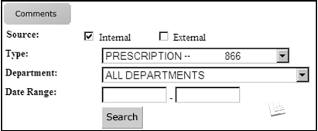  Result: Rx Level comments related to the previously selected prescription displays.
5 | Determine the subject of the most recent Ship Consent comment displayed about this prescription.  Notes:  - Each attempt made to reach the beneficiary will result in a new Rx Level comment.  - Each comment includes:  - Date and time of the contact  - Result of the attempt, which appears as the Subject  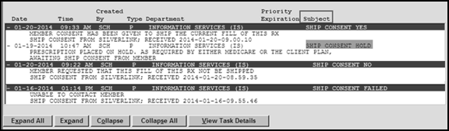
5 | If the Subject of the most recent comment is… |  | Then… | Then…
5 | SHIP CONSENT YES  Sample Comment: Beneficiary consent has been given to ship the current fill of this Rx; Ship consent via <method>; Received YYYY-MM-DD |  | Consent was received via one of the following methods to ship the order:  - Ship Consent Call (IVR)  - Call to Customer Care (PeopleSafe)  - Via Web (Caremark.com) | We received your consent to ship your medication(s) through <method> on YYYY-MM-DD.
5 |  |  |  | If the contact date was… |  | Then…
5 |  |  |  | More than 2 business days ago |  | Check the status of the order on the Main screen. Refer to the Order Status.
5 |  |  |  | Less than 2 business days ago |  | Your medication(s) should ship within 5 business days.
5 | SHIP CONSENT NO  Sample Comment: Beneficiary requested that this fill of this Rx not be shipped; Ship consent from <method>; Received YYYY-MM-DD |  | Consent was received via one of the following methods to stop shipment of the order:  - Ship Consent Call (IVR)  - Call to Customer Care (PeopleSafe)  - Via Web (Caremark.com) | We received your consent to stop shipment of your medication(s) through <method> on YYYY-MM-DD.  - This order can now be placed through the normal refill process.  Process Note: Refer to Prescription (Rx) Refill/Renewal (Order Placement).
5 | SHIP CONSENT HOLD  Sample Comment: Prescription placed on hold. As required by either Medicare or the client plan, awaiting Ship Consent from beneficiary. |  | The order has been adjudicated and is awaiting consent from the beneficiary. | Process Note: Refer to the Processing Ship Consent Hold Prescriptions/Orders section of this document to obtain consent as to whether the beneficiary wants to ship this order.  Note: Beneficiaries are able to provide consent and release orders placed on Ship Consent Hold after the 72 hour window. Beneficiaries will no longer need to call Customer Care to provide consent to release the order hold. This includes both Patient Denied Ship Consent (Reason code 31) and Patient Ignored Ship Consent (Reason code 32).
5 | SHIP CONSENT FAILED  Sample Comment: Unable to contact beneficiary. |  | Unable to contact the beneficiary to obtain consent for an order on Ship Consent Hold.  OR  Caller answers and does not complete Ship Consent Process or disconnects. | We attempted to obtain consent to ship your medication(s) via your preferred method of contact/CMP on YYYY-MM-DD.
5 |  |  |  | If this contact attempt was… | Then…
5 |  |  |  | Multiple failed call attempts | - I apologize that our efforts to reach you were unsuccessful.  - This order can now be placed through the normal refill process.  Process Note: Refer to the Prescription (Rx) Refill/Renewal (Order Placement).
6 | Repeat Steps 2-5 of this section for each prescription inquiry.
7 | Ask if there are any other benefit questions.
7 | If… | Then…
7 | Yes | - Address any benefit issues.  - Log Activity: 304 = Manual Refill
7 | No | Document and close the call according to current policies and procedures. Refer to the MED D - Call Documentation.  Note: Documentation should include who provided Expressed consent (Example: Beneficiary, POA, AOR, Legal Representative, etc.)  Log Activity: 304 = Manual Refill

Top of the Document

PACE Plans Excluded from Expressed Consent
Within the CMS guidance for EXPRESSED Consent, PACE plans are excluded from providing expressed consent on ANY prescriber-initiated orders (call, fax, eRX).

The following clients meet these criteria:
Client Code | Client Name | Carrier Code
X7601 | FALLON SENIOR PLAN PACE | 7601

Top of the Document

Authorized Persons Who Can Give Expressed Consent
Beneficiaries (and designated individuals with POA or AOR/Legal representative documentation) can provide Expressed Consent for a prescription/order on Ship Consent Hold.

For designated/legal representatives, appropriate documentation MUST be viewable in PeopleSafe or FACETS prior to obtaining Expressed Consent. Refer to the MED D - Appointed Representative Form (AOR) or Power of Attorney (POA).

Before speaking to specific Rxs on Consent Hold, first attempt to have the beneficiary verify the names or Rx # of the drugs.
- If the beneficiary asks what medications are on hold and is struggling to provide a drug name for verification, disclose the names of those medications because the beneficiary is calling for their medication.

If no POA or AOR on file, non-authorized party callers can provide Expressed Consent in accordance with guidance found in the HIPAA Authentication Grid including Questions and Answers.
- Non-authorized party callers must verify the Rx # or Rx name before the CCR can accept Expressed Consent for that particular prescription/order.
  - If the Non-authorized party (not the beneficiary, POA or AOR) asks what medications are on hold and is struggling to provide a drug name for verification, do not disclose the names of those medications.
    - The following individuals are some, but not all, examples of a Non-authorized party caller:
      - Beneficiary’s spouse/child
      - Neighbor
      - Long Term Care nurse
Unless the Prescriber is the beneficiary, Prescribers cannot provide consent for prescriptions they ordered. This would defeat the intention of Expressed Consent.

Top of the Document

Processing Ship Consent Hold Prescriptions/Orders
Prescriptions/Orders are adjudicated first per plan design in order to ensure they are clean (no rejections based on plan design, such as plan limitations, prior authorization required, etc.) and then are placed on a NEW hold while awaiting the beneficiary’s consent.

Reminders: Four (4) phone attempts will be made to contact the beneficiary over a period of (2-3) days. If the beneficiary elected email or text alert, they will receive one message for 3 days.
- A letter will be sent to the beneficiary if telephone, text, or email outreach was unsuccessful.
- The prescription will change to a status of REJ HOLD.

When addressing a prescription/order on Ship Consent Hold, complete the following steps:
Step | Action
1 | Locate any orders that are on Ship Consent Hold (REJECT SCH HOLD).  Do NOT transfer callers to dedicated teams until orders on Ship Consent Hold have been addressed.  Note: Status of Ship Consent Hold is viewable on the Main and Order Status screens of PeopleSafe.  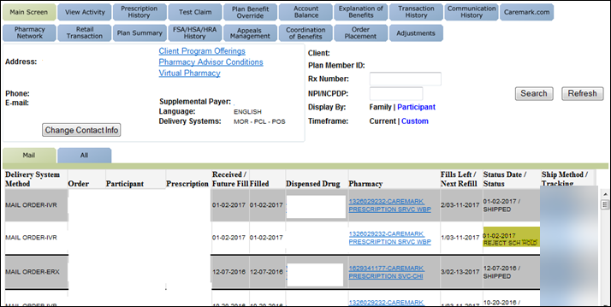  If the beneficiary says that they no longer take a medication or that the prescriber has stopped the medication, release the order from REJECT SCH HOLD status (Select Don’t Ship).  - Do NOT cancel or discontinue orders the caller does not want shipped.  - Do NOT submit any tasks to cancel these orders.  - Canceling an order does not remove it from the Ship Consent Hold queue and causes an internal system error.  - Selecting Don’t Ship disenrolls any prescription from the Automatic Refill Program.  - If the beneficiary later wants to resume taking this medication, a new order will need to be placed.  Notes:  - If a beneficiary calls to provide consent for an order not yet in Ship Consent Hold, advise the beneficiary that the order is still being processed and s/he will receive a Ship Consent Call, Text, or Email when the order is ready to be shipped.  - Refer to Discontinued Prescription and Cancel Order or Prescription Refill or New Prescription.  Do NOT expedite orders to bypass Ship Consent Calls and rush the order to Ship Consent Hold queue.  Return to High Level Process
2 | Determine the status of the medications in question by asking the caller what prescription (s)/order(s) they are calling about.  - Save the specific order # (REJECT SCH HOLD), Rx # and Rx name(s) the caller asked about to the NotePad.  Return to High Level Process
3 | - Once the prescription/order has been identified on the Main screen, click on the Order Placement button.  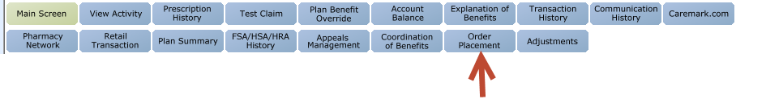  Ship Consent Hold will not be a Care-actionable item within the Prescription Details or Order Status screens.  - To release an order from Ship Consent Hold, navigate to the Order Placement screen.  Return to High Level Process
4 | - Select ALL the prescription(s) on SHIP CONSENT HOLD from the Order Placement screen.  - Select all prescriptions/orders on Ship Consent Hold and eliminate the need for more callbacks.  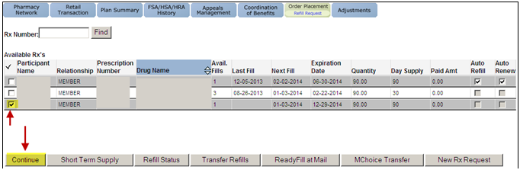  - Click the Continue button.  Result: Ship Consent Hold Rx screen display  Return to High Level Process
5 | Obtain Expressed Consent for the medications listed based on the caller. Refer to the Authorized Persons Who Can Give Expressed Consent section of this document to determine what criteria the caller must provide about a prescription/order before Expressed Consent can be accepted.  Return to High Level Process
5 | If the caller is… |  |  |  | Then obtain Expressed Consent for…
5 | Beneficiary, POA, or and/or legal representative |  |  |  | ALL prescriptions/orders on Ship Consent Hold.
5 | Non-authorized party |  |  |  | Only those prescriptions/orders the caller verified by Rx # or name.  Select the Don’t Ship radio button for any prescription not verified by the caller.  Result: Beneficiary receives a letter about these prescriptions and they will revert back to the standard refill process.
5 | Click the appropriate radio button for each prescription, based on caller’s response.  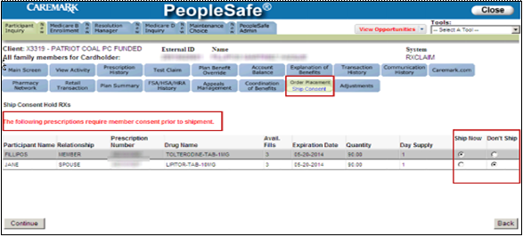  Note: If the Ship Now/Don’t Ship options are not available, proceed to click the Continue button to continue to process the order.
5 | If the caller says… |  | Then select…
5 | I want this medication. |  | Ship Now  Result: Option ships the order and stops the Ship Consent Request Notifications.
5 | I do NOT want this medication. |  | Don’t Ship  - Continue through the pop-up window that states the prescription will be removed from the Refill Summary screen.  Result: Don’t Ship will place the prescription on Beneficiary Initiated Hold and will stop the Ship Consent Calls.  Select Don’t Ship from the Ship Consent Hold Rxs screen to prevent any unwanted orders from shipping.  - Do NOT cancel or discontinue orders the caller does not want shipped.  - Do NOT submit any tasks to cancel these orders.  - Canceling an order COMPLETELY removes it from the system and the order is no longer available for standard refill processes if the beneficiary wants to refill the order at a later date.
5 | I would like to discontinue this medication |  | Refer to Discontinued Prescription.
5 | Click the Continue button.  Result: Refill Summary screen displays.
6 | Continue as a Refill Order. Refer to the Prescription (Rx) Refill/Renewal (Order Placement), Refill Process section.  - Verify if the co-pay/order amount is more than $1000 on the Refill Summary screen.  Return to High Level Process
6 | If the co-pay/order amount is… |  |  | Then…
6 | More than $1000 High Copay |  |  | - Enter a Member Level note to indicate the beneficiary’s payment authorization once the refill is completed.  Example: REJECT SCH HOLD Order #<xxxxxxx>, beneficiary is aware and authorizes the charges in the amount of <order amount> charged to <payment type> <last 4 digits of account> <exp date, if cc>.  - Copy the language in the above example exactly, changing only the information specific to the beneficiary.  - This note will avoid additional calls placed to the beneficiary to obtain payment authorization.  - A Stop See comment is not needed.  - Any Member Level notes entered will be viewable by Accounts Receivable.
6 | Less than $1000 |  |  | Proceed to the next step.
7 | - Click on the Charge Payment button to complete processing of the caller’s consent.  Note: When the Charge Payment button is not available, then Save the order if there is a $0 copay. Orders received without a payment method included will cause the prescription order to process with an invoice. For Beneficiaries requesting to process an order and NOT provide a payment at point of sale, suggest mailing in the order or have needed prescriptions transferred to a local pharmacy.  Result: Refill confirmation number displays.  Note: If the beneficiary has a default payment on file and would like to authorize payment instead of receiving an invoice (if allowed), enter the following Member Level note.  Example: REJECT SCH HOLD Order #<xxxxxxx>, beneficiary is aware and authorizes the charges in the amount of <order amount> charged to <payment type> <last 4 digits of account> <exp date, if cc>.  - Copy the language in the above example exactly, changing only the information specific to the beneficiary.  Return to High Level Process
8 | - You may still receive additional calls or letters about this/these medication(s).  - If you receive a call to authorize consent or payment for this/these orders, please:  - Listen to the call in its entirety for all medications that require consent.  - Say Yes for any medications you would like to receive.  - We apologize for any inconvenience. It applies to ALL Medicare Part D plans; it is not specific to CVS/Caremark.  - The system updates several times during the day.  - Our updates and your consent may overlap.  CCR Process Note:  - Placing a prescription on Ship Consent Hold and the CCR receiving Expressed Consent from the beneficiary are not processed by the Care Consent Call vendor in real time.  - The system pulls data on prescriptions to be placed on or removed from Ship Consent Hold 4 (four) times a day.  - Calls, letters and processing Expressed Consent can overlap, based on the timing of the data pull and the processes within this work instruction being completed.  - Even though the CCR has received and processed Expressed Consent from the beneficiary or designated individual, there is still a possibility of verifications calls and/or letters being made/sent to the beneficiary  - Once consent is obtained, the order will continue processing and a pharmacist will complete a repeat safety check to ensure the beneficiary’s clinical profile has not changed since consent was received. The order may be delayed if the safety check requires an outreach to the prescriber.  Return to High Level Process
9 | Is the caller one of the following individuals:  - Beneficiary  - Authenticated SHIP Counselor. Refer to the MED D - SHIP Counselor Calls For CVS Caremark Part D Plans.  - Designated individuals with Power of Attorney (POA) or legal representative documentation.  Return to High Level Process
9 | If… | Then…
9 | Yes | - You now have additional options to provide Consent for these types of orders instead of receiving phone calls or calling in to MED D Customer Care.  - Would you like to hear about these options?
9 | Yes | If… |  |  |  | Then…
9 | Yes | Yes |  |  |  | Refer to the Care Consent Notification Options section of this document.
9 | Yes | No |  |  |  | - You will continue to receive Ship Consent calls when orders are ready to ship.  - Listen to the call in its entirety for all medications that require consent.  - Yes for any medications you would like to receive.  - If you should change your mind and want to receive Ship Consent notifications by email or text in the future, please call MED D Customer Care back and we will be happy to set that up for you.  Proceed to the next step.
9 | No | Proceed to the next step.
10 | Ask if there are any other benefit questions.  Return to High Level Process
10 | If… | Then…
10 | Yes | - Address any benefit issues  - Document and close the call according to existing policies and procedures. Refer to the MED D - Call Documentation.  Note: Documentation should include who provided Expressed consent (Example: Beneficiary, POA, AOR, Legal Representative, etc.)  Log Activity: 304 - Manual Refill
10 | No | Document and close the call according to current policies and procedures. Refer to the MED D - Call Documentation.  Note: Documentation should include who provided Expressed consent (Example: Beneficiary, POA, AOR, Legal Representative, etc.)  Log Activity: 304 - Manual Refill

Top of the Document

Ship Consent Requested Notification Options
Changes to Ship Consent Requested notification changes can only be completed by the following individuals:
- Beneficiary
  - Authenticated SHIP Counselor. Refer to MED D - SHIP Counselor Calls For CVS Caremark Part D Plans.
- Designated individuals with Power of Attorney (POA) or legal representative documentation
  - Legal documentation must be viewable in PeopleSafe (Priority Comments or Med D tab View Comments) in order for the CCR to proceed with contact information updates. Refer to MED D SilverScript - Appointed Representative Form AOR or Power of Attorney POA.

Non-authorized Party Callers (benefits offices, prescribers, individuals calling on behalf of the beneficiary without legal documentation) are NOT authorized to confirm or update contact information for the beneficiary.

Perform the steps below when a beneficiary, POA or legal representative wants to change how s/he will receive Ship Consent notifications:
Step | Action
1 | In PeopleSafe, verify if the beneficiary wants to be asked about email on the Main screen of the Participant Inquiry tab.
1 | If the email field displays… |  | Then…
1 | ** DON’T ASK FOR EMAIL** |  | - Instead of receiving phone calls, you could receive a text message alerting you when an order was ready to ship.  - Would you be interested in receiving these alerts via text message in the future?
1 |  |  | If… | Then…
1 |  |  | Yes | Proceed to Step 2.
1 |  |  | No | - I understand.  - You will continue to receive Ship Consent calls when orders are ready to ship.  - Listen to the call in its entirety for all medications that require consent.  - Say Yes for any medications you would like to receive.  - If you should change your mind and want to receive Ship Consent notifications by email or text in the future, please call MED D Customer Care back and we will be happy to set that up for you.  Proceed to Step 4.
1 | Anything Else |  | - Instead of receiving phone calls, you could receive an email or text message alerting you when an order was ready to ship.  - Would you be interested in receiving these alerts via email or text message in the future?
1 |  |  | If… | Then…
1 |  |  | Yes to text message | Proceed to Step 2.
1 |  |  | Yes to email | Proceed to Step 3.
1 |  |  | No | - I understand.  - You will continue to receive Ship Consent calls when orders are ready to ship.  - Listen to the call in its entirety for all medications that require consent.  - Say Yes for any medications you would like to receive.  - If you should change your mind and want to receive Ship Consent notifications by email or text in the future, please call MED D Customer Care back and we will be happy to set that up for you.  Proceed to Step 4.
2 | - Click the Change Contact Info button.  Result: Contact Info screen displays.  - Verify if a Cellular Phone number is on file.
2 | If… | Then…
2 | Yes | Confirm that TEXT is listed under the Default column for the Cellular number.  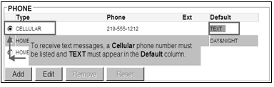
2 | Yes | If TEXT is… |  | Then…
2 | Yes | Listed |  | Under the MESSAGING PREFERENCES section of the screen:  - Navigate to the Order Status heading  Note: Text radio button is selected.  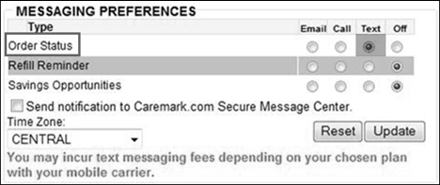  - You are set up to receive text messages.  - All order status updates will be sent through text messages.  - Ship Consent text notifications are now available.  - At that time, you will be able to provide Consent for orders that are ready to ship with your cell phone.  Proceed to Step 4.
2 | Yes | NOT listed |  | - Select the radio button for the Cellular number.  - Click the Edit button.  - Check the Text Messages box.  - Click the Save button.  - Under the MESSAGING PREFERENCES section of the screen:  - Navigate to the Order Status heading  - Select the Text radio button.  - You are set up to receive text messages.  - All order status updates will be sent through text messages.  - Ship Consent text notifications are now available.  - At that time, you will be able to provide Consent for orders that are ready to ship with your cell phone.  Proceed to Step 4.
2 | No | - Click the Add button.  - Complete the information under the Add/Edit Phone section.  - Click the Save button.  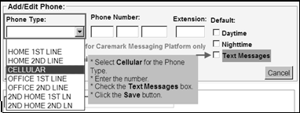  - Under the MESSAGING PREFERENCES section of the screen:  - Navigate to the Order Status heading  - Select the Text radio button.  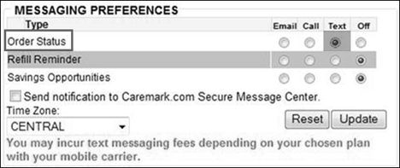  - You are set up to receive text messages.  - All order status updates will be sent through text messages.  - Ship Consent text notifications are now available.  - At that time, you will be able to provide Consent for orders that are ready to ship with your cell phone.  Proceed to Step 4.
3 | Verify that an email address is listed on the Main screen of the Participant Inquiry tab in PeopleSafe.
3 | If… | Then…
3 | Yes | Under the MESSAGING PREFERENCES section of the screen:  - Navigate to the Order Status heading  - Select the Email radio button.  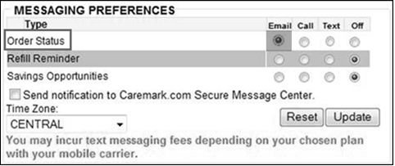  - You are set up to receive email messages.  - All order status updates will be sent through email messages.  - Ship Consent email notifications is now available.  - At that time, you will be able to provide Consent for orders that are ready to ship through a link sent to your email address.  Note: To guarantee delivery of CMP alerts beneficiaries should add alerts.CVSCaremark@RxHealthAlerts.com to their address book. Refer to Handling CMP Inquiries for details.  Proceed to Step 4.
3 | No | - Click the Change Contact Info button.  Result: Contact Info screen displays.  - Under the EMAIL ADDRESS section, enter the email address.  - Click the Update button.  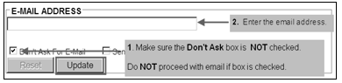  - Under the MESSAGING PREFERENCES section of the screen:  - Navigate to the Order Status heading  - Select the Email radio button.  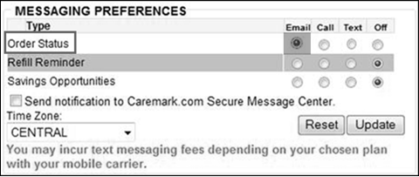  - You are set up to receive email messages.  - All order status updates will be sent through email messages.  - Ship Consent email notifications are now available.  - At that time, you will be able to provide Consent for orders that are ready to ship through a link sent to your email address.  Proceed to the next step.
4 | Ask if there are any other benefit questions.
4 | If… | Then…
4 | Yes | - Address any benefit issues  - Document and close the call according to existing policies and procedures. Refer to the MED D - Call Documentation.  Note: Documentation should include who provided Expressed consent (Example: Beneficiary, POA, AOR, Legal Representative, etc.)  Log Activity: 304 - Manual Refill
4 | No | Document and close the call according to current policies and procedures. Refer to the MED D - Call Documentation.  Note: Documentation should include who provided Expressed consent (Example: Beneficiary, POA, AOR, Legal Representative, etc.)  Log Activity: 304 - Manual Refill

Top of the Document

Returned Goods
Standard Returned Goods processes apply for any orders shipped after Expressed Consent has been provided.

The Centers for Medicare and Medicaid (CMS) requires that CVS Caremark offer a full refund to the Beneficiary for any unwanted or unneeded prescriptions refilled through the Automatic Refill Program, regardless of whether the medication is returned by the Beneficiary (or by a representative of the Beneficiary), unless the prescription has been either partially or fully consumed.

Consent Bypassed
It is a CMS requirement under this exception to allow a beneficiary unlimited returns/refunds for orders containing unused medications, where consent was not provided, and the beneficiary states that the drug(s) is not needed or not wanted.

If a beneficiary advises they would prefer to require consent for all Mail orders not requested by them, update the beneficiary’s profile.

CCR Process Note: To determine the number RBPs (Return by Participant) CCRs will:
- Access Transaction History in PeopleSafe
- Review Notes/comments to determine reason for return

Refer to MED D - Return Order for Refund - Copay Credit (Formerly Mail Tag Request) for more information regarding mail tags.

Top of the Document

Beneficiary Calls to Cancel Order Previously Consented For
There may be situations when a beneficiary has called to consent to an order and then calls back (the same day) to cancel the order.
Only the beneficiary or a legally documented representative may cancel an order or prescription.

Perform the following:
Step | Action
1 | Check the status of the order in PeopleSafe.  Refer to Cancel Order or Prescription - Refill or New Prescription for more information.

Top of the Document

Adding/Removing Consent Required on Future Orders

Perform the following steps to add or remove consent:
Step | Action
1 | On the Main screen, click the Maintain Patient Profile button at the bottom of the screen.  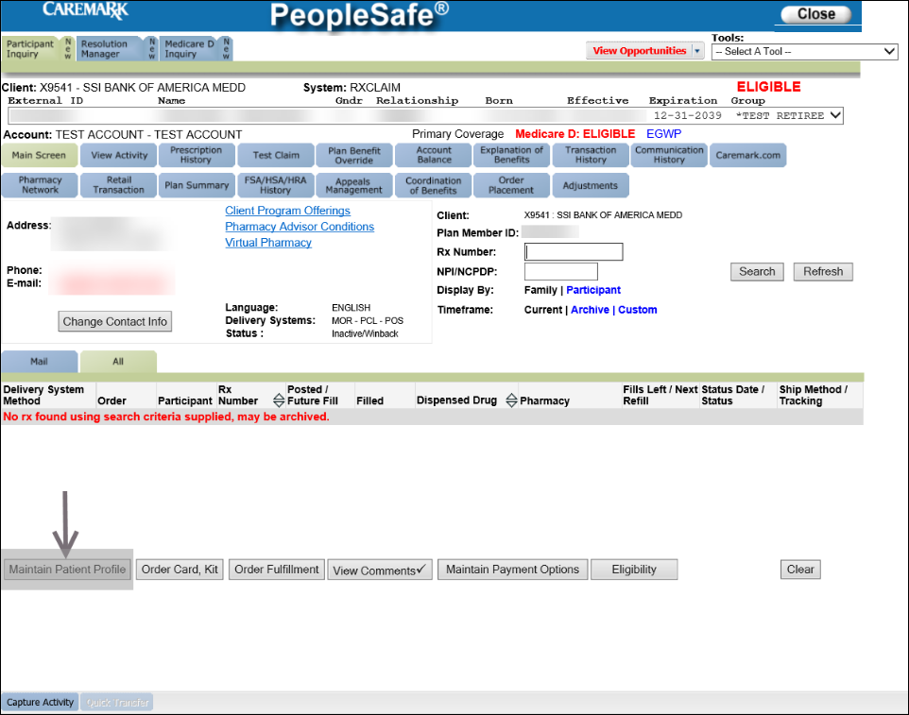  Result: The Patient Profile screen displays.
2 | Click the SCH Status button.  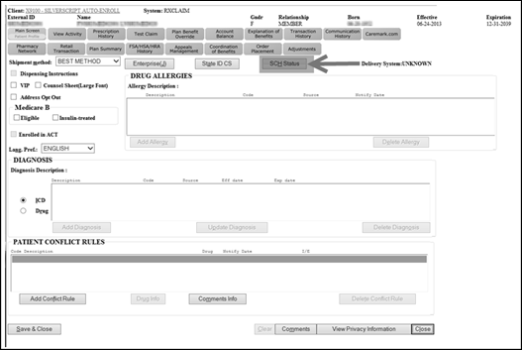  Result: The SCH Maintenance screen displays.
3 | On the SCH Maintenance screen:
3 | If… | Then…
3 | Adding Consent  Only for beneficiaries who:  - Prefer to consent to each and every Mail order  - Are moving to an LTC facility and they do not need their mail order  CCRs are NOT to enter a Stop See comment to account when beneficiary requests to consent to each and every Mail order. | - Inform the beneficiary that consent is required for each and every Mail order Rx.  Note: Opting into SCH affects ALL medications on the account.  - Select the ON radio button next to SCH to add required consent.  - Select the appropriate choice from the SCH Reason dropdown menu (MBR PREFERENCE).  - Click the Add button.  Result: The selection is saved. Click the Close button to close the window.
3 | Removing Consent  Only for beneficiaries who:  - Have self-opted in  - Have filled at least one/any RX using CVS/Caremark Mail Service Pharmacy under their current plan in the past twelve (12) months  - Have contacted us to advise they are no longer in an LTC facility | Select the OFF radio button. To remove changes, select the Clear button, which returns the screen to the original status.
3 | CCR Process Note: If the SCH Reason dropdown does not populate and you are unable to complete this step, perform the following:  - Educate the caller the request will be made to update consent required.  - Warm Transfer to the Senior Resolution Team Escalation Line to complete this process.  Hello, my name is < >and I am calling from < >. I need to have the Ship Consent turned back on for this account. I have educated the beneficiary on the process and they have been made aware that the consent is being placed back on the account and will be needed for future orders.  Note: SRT Escalation will update consent. Continue the call as normal.  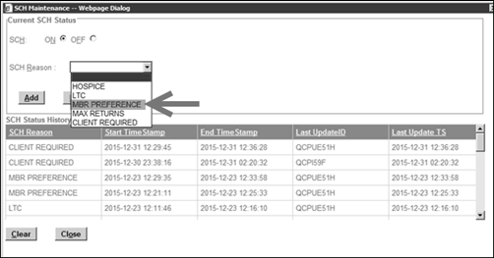

Top of the Document

Resolution Time
This will vary based on the beneficiary’s response to the Ship Consent Requested Notifications and/or the type of hold on the prescription.
Order Expected Ship Date = Once consent has been received, the order will ship within 5 business days.

Top of the Document

FAQs

Use the following tables of Frequently Asked Questions (FAQs) to address questions:

Expressed Consent Billing and Payment Questions
1 | Why did I receive an invoice with my prescription order?  Isn’t my credit card/checking account on file for you to use? | - After some verification, I see that your doctor submitted new prescriptions for processing on your behalf.  - Because your doctor is not able to verify your payment account on file, your order was shipped with an invoice.  - I apologize for any inconvenience this may have caused.  - I am more than happy to assist with your payment at this time.

How does Expressed Consent Affect Orders
2 | I see a voided order on my account at Caremark.com.  Has my order been cancelled? | - No.  - We have received consent for your order.  - The voided order you see is part of normal processing.  - A new order with the same prescription number(s) will be viewable shortly.  - Your order will ship within 5 business days.
3 | The beneficiary said the letter they received only mentioned one medication, but two were received.  Why didn’t the vendor attempt to contact the beneficiary about the other medication? | - View the letter sent to the beneficiary in the Communications History tab in PeopleSafe to verify which medications were listed on the letter.  - The beneficiary should receive only ONE letter per order even if multiple medications are included in the order.  - The letter should list all the medications in the order that have been placed on Ship Consent Hold.  - Refer to the Viewing Ship Consent Notes in PeopleSafe section of this work instruction to confirm how many contact attempts have been made to the beneficiary about each prescription and the respective outcomes.

Who Can Handle Expressed Consent Calls?
4 | The Calls Transferred from the Interactive Voice Response (IVR) System work instruction, says that calls transferred from the IVR can be handled by Customer Care even if the client has a dedicated team, but once the call becomes more than that, such as questions about co-pays or plan design, then warm transfer the call to the dedicated team.  Will the Expressed Consent changes affect this so that all MED D refills must be handled by a MED D representative? | - Yes, Commercial Customer Care reps will warm transfer ALL Med D call types to the appropriate Med D Care phone number. This is due to new regulations regarding automatic refills and the increased complexity in handling MED D calls.  This applies to Commercial CCRs that are only skilled to take Commercial calls. It does not apply to EGWP CCRs.  - MED D calls on the following subjects should be transferred to a MED D trained CCR (MED D or EGWP):  - Basic MED D refills and order status  - MED D Automatic Refill Program calls  - MED D co-pays and/or plan design
5 | The interim screen displays when a prescription is on Ship Consent Hold and is selected on the Refill Request screen.  If the call would route to general Customer Care because the beneficiary does not follow the procedure left in the Ship Consent Call message and calls the telephone number printed on their bottle, will the Interim screen and Ship Consent hyperlink be visible if the CCR does not have the MED D role code? | - Yes, the Ship Consent hyperlink will be based on the account (MED D account vs. a Commercial account) NOT the CCR’s role code.  - For MED D Automatic Refill Program calls, the call should be transferred to a MED D trained CCR (Commercial or MED D)
6 | My phone number is on the Do Not Call list, how can I be notified about consent? | If the beneficiary does not want text or email - provide info that letter will be sent but this may delay the order as they have to wait to receive the letter before they know to provide consent.

Top of the Document

Related Documents
Grievance Standard Verbiage (for use in Discussion with Beneficiary) section in MED D - Grievances Index

Parent SOP: CALL-0048: Medicare Part D Customer Care Call Center Requirements-CVS Caremark Part D Services, L.L.C.
Abbreviations/Definitions: Abbreviations / Definitions

Top of the Document
Not to Be Reproduced or Disclosed to Others without Prior Written Approval
ELECTRONIC DATA = OFFICIAL VERSION - PAPER COPY = INFORMATIONAL ONLY

